**MAP524 Lab3**

**Name: Sanghyuk Lee**

**Student No: 129405171**

1. **Reflection**
2. **Important code (Not all of them)**
3. **Screenshot**

**<Reflection>**

To explain briefly, Lab3 is not a temporary storage but an application that contains the stored information even if you turn the app off and on.

I updated the Bundle.gradle to use Room db and then sync.

After making the entire Donation object @entity and specifying the @primary key and set the field sharingApps @Ignore not to use in my database.

I created a database class and used Dao to specify functions to be used in the database.

After checking if the database is empty or not through DatabaseClient, decide which database to use. After that, add the value to Dao using the function I specified through the executor.

MainActivity uses DatabaseClient's insertToDB function to forward objects to the database.

To get a data what I wanted in detail, I used the specific function of Dao class in 'AllDonation' java class which is used to display all the donations records and 'AllDonationsWithAmountBiggerThan' java class which displays the records having the amount more than 1000, which I set and send it to parameter.

I've used activity_all_donations for 'AllDonation' and 'AllDonationsWithAmountBiggerThan' because both of the form displaying are the same.

And changed the ArrayList to Array in Adapter as I am not going to use ArrayList anymore in Lab3.

What I could learn through lab3 is with a knowledge of dealing with database, now I am available to store the data in database so that even if I accidently turn off the application, I don’t need to worry as I know there is a stored data when I run the app.

**MainActivity**

**public class** MainActivity **extends** AppCompatActivity {  
  
 DatabaseClient **dbClient**;  
 Button **donate**;  
 RadioButton **paypal_payment**;  
 RadioButton **credit_payment**;  
 CheckBox **whatsup_check**;  
 CheckBox **messenger_check**;  
 CheckBox **messages_check**;  
 EditText **amount**;  
 Donations **currentDonation**;  
 Donations **reportDonation**;  
 AlertDialog.Builder **builder**;  
 **int pType** = 0;  
 **int**[] **sharingArray** = {0,0,0};*//what'sup,massenger,text* **int sharingIndex** = 0;  
 ArrayList<Donations> **donationsArrayList** = **new** ArrayList<>(0);  
  
 @Override  
 **protected void** onCreate(Bundle savedInstanceState) {  
 **super**.onCreate(savedInstanceState);  
 setContentView(R.layout.***activity_main***);  
 **builder** = **new** AlertDialog.Builder(**this**);  
 **donate** = (Button) findViewById(R.id.***donate_id***);  
 **paypal_payment** = (RadioButton)findViewById(R.id.***paypal_btn***);  
 **credit_payment** = (RadioButton)findViewById(R.id.***credit_btn***);  
 **whatsup_check** = (CheckBox)findViewById(R.id.***wup_check***);  
 **messenger_check** = (CheckBox)findViewById(R.id.***messenger_check***);  
 **messages_check** = (CheckBox)findViewById(R.id.***messages_check***);  
 **amount** = (EditText) findViewById(R.id.***amount***);  
 **dbClient** = DatabaseClient.*getInstance*(**this**);  
 *//DonationDataBase db = Room.databaseBuilder(this, DonationDataBase.class, "donationDB").build();* }  
  
 **public void** saveDonation(View view) {  
  
 Toast.*makeText*(getApplicationContext(),R.string.***messege***,Toast.***LENGTH_SHORT***).show();  
 String payment, sharing=**" and sharing the link via "**;  
 **if** (**paypal_payment**.isChecked()) { *//1 for credit 2 for Paypal* payment = **"PayPal"**;  
 **pType** = 2;  
 }  
 **else**{  
 payment = **"Credit card"**;  
 **pType** = 1;  
 }  
 **sharingArray** = **new int**[]{0,0,0};  
 Boolean shared = **false**;*//what'sup,text,massenger* **if** (**whatsup_check**.isChecked()) {  
 sharing += **"What's up"**;  
 **sharingArray**[0] = 1;  
 shared = **true**;  
 }  
 **if** (**messenger_check**.isChecked()) {  
 sharing += **" massenger "**;  
 **sharingArray**[2] = 1;  
 shared = **true**;  
 }  
 **if** (**messages_check**.isChecked()) {  
 sharing += **" messages"**;  
 **sharingArray**[1] = 1;  
 shared = **true**;  
 }  
 **if** (!shared)  
 sharing=**""**;  
 **int** a = Integer.*parseInt*(**amount**.getText().toString());  
 **currentDonation** = **new** Donations(**pType**,a);  
 **reportDonation** = **new** Donations(**pType**,a,**sharingArray**);  
 DatabaseClient.*insertToDB*(**this**, **currentDonation**);  
 *//donationsArrayList.add(currentDonation);* **builder**.setMessage(**"Thanks for your "** +payment + **" payment with amount "** + a +sharing )  
 .setCancelable(**true**)  
 .setPositiveButton(**"OK"**, (dialog, id) -> setUI());  
 AlertDialog alert = **builder**.create();  
 alert.setTitle(**"AlertDialogExample"**);  
 alert.show();  
  
 }  
  
 @Override  
 **public boolean** onCreateOptionsMenu(Menu menu) {  
 MenuInflater inflater = getMenuInflater();  
 inflater.inflate(R.menu.***donationapp_menu***, menu);  
 **return true**;  
 }  
  
 @Override  
 **public boolean** onOptionsItemSelected(@NonNull MenuItem item) {  
 **super**.onOptionsItemSelected(item);  
 **switch** (item.getItemId()){  
 **case** R.id.***reportMenuItem***: {  
 Intent myIntent = **new** Intent(**this**, DonationReport.**class**);  
 myIntent.putExtra(**"reportDonation"**, **reportDonation**);  
 startActivity(myIntent);  
 setUI();  
 }  
 **case** R.id.***resetUI***:{  
 setUI();  
  
 }  
 **case** R.id.***donations_list_id***:{  
 *//DatabaseClient.insertToDB(this, currentDonation);* Intent allDonationsIntent = **new** Intent(**this**,AllDonations.**class**);  
 startActivity(allDonationsIntent);  
  
 }  
 **case** R.id.***donations_amount_bigger***:{  
 *//DatabaseClient.insertToDB(this, currentDonation);* Intent allDonationsIntent = **new** Intent(**this**,AllDonationsWithAmountBiggerThan.**class**);  
 startActivity(allDonationsIntent);  
  
 }  
 }  
  
  
 **return true**;  
  
 }  
  
 **public void** setUI(){  
 **paypal_payment**.setChecked(**false**);  
 **credit_payment**.setChecked(**false**);  
 **whatsup_check**.setChecked(**false**);  
 **messages_check**.setChecked(**false**);  
 **messenger_check**.setChecked(**false**);  
 **amount**.setText(**""**);  
 }  
}

**Donation**

@Entity  
**public class** Donations **implements** Parcelable {  
  
 @PrimaryKey(autoGenerate = **true**)  
 **public int id**;  
  
 **int paymentMethod**; *// 1 for credit and 2 for paypal* **double amount**;  
  
 @Ignore  
 **int**[] **sharingApps**;  
  
  
 **public** Donations(**int** paymentMethod, **double** amount) {  
 **this**.**paymentMethod** = paymentMethod;  
 **this**.**amount** = amount;  
 }  
  
  
 **public** Donations(**int** paymentMethod, **double** amount, **int**[] sharingApps) {  
 **this**.**paymentMethod** = paymentMethod;  
 **this**.**amount** = amount;  
 **this**.**sharingApps** = sharingApps;  
 }  
  
 **protected** Donations(Parcel in) {  
 **paymentMethod** = in.readInt();  
 **amount** = in.readDouble();  
 **sharingApps** = in.createIntArray();  
 }  
  
 **public static final** Creator<Donations> ***CREATOR*** = **new** Creator<Donations>() {  
 @Override  
 **public** Donations createFromParcel(Parcel in) {  
 **return new** Donations(in);  
 }  
  
 @Override  
 **public** Donations[] newArray(**int** size) {  
 **return new** Donations[size];  
 }  
 };  
  
 @Override  
 **public int** describeContents() {  
 **return** 0;  
 }  
  
 @Override  
 **public void** writeToParcel(Parcel dest, **int** flags) {  
 dest.writeInt(**paymentMethod**);  
 dest.writeDouble(**amount**);  
 dest.writeIntArray(**sharingApps**);  
 }  
}

**DonationReport**

**public class** DonationReport **extends** AppCompatActivity {  
  
  
 @Override  
 **protected void** onCreate(Bundle savedInstanceState) {  
 **super**.onCreate(savedInstanceState);  
 setContentView(R.layout.***donation_report_layout***);  
 Donations obj = getIntent().getParcelableExtra(**"reportDonation"**);  
 TextView reportText = (TextView) findViewById(R.id.***report_id***);  
 reportText.setText(buildStringReport(obj));  
  
 }  
  
  
 **public** String buildStringReport (Donations obj){  
 String sharingArray = **" and sharing the campaign via "**;  
 String payment = **""**;  
 **boolean** isShard = **false**;  
 *//what'sup,text,massenger* **if** (obj.**sharingApps**[0] == 1){  
 sharingArray += **" What's up"**;  
 isShard = **true**;  
 }  
 **if** (obj.**sharingApps**[1] == 1){  
 sharingArray += **" text masseges"**;  
 isShard = **true**;  
  
 }  
 **if** (obj.**sharingApps**[2] == 1){  
 sharingArray += **" massenger"**;  
 isShard = **true**;  
  
 }  
  
  
 **if** (obj.**paymentMethod** == 1)*//1 for credit 2 for Paypal* payment = **"Credit Card"**;  
 **else** payment = **"PayPal"**;  
  
 **if** (isShard)  
 **return "Thanks for your "** + payment + **" payment with amount "** + obj.**amount** + sharingArray;  
 **else  
 return "Thanks for your "** + payment + **" payment with amount "** + obj.**amount** ;  
  
  
  
 }  
}

**DonationDataBase**

@Database(entities = {Donations.**class**}, version = 1)  
**public abstract class** DonationDataBase **extends** RoomDatabase {  
 **public abstract** DonationDao DonationDao ();  
}

**DonationDao**

@Dao  
**public interface** DonationDao {  
  
 @Query(**"SELECT * FROM Donations"**) *//Select all the donations from Donations.java class* **public** Donations[] getAllDonations();  
  
 @Query(**"SELECT * FROM Donations WHERE amount > :amount"**) *//Select all the donations from Donations.java class* **public** Donations[] getAllDonationWithAmountBiggerThan(**int** amount);  
  
 @Insert  
 **public void** insertDonation(Donations user);  
  
}

**Donationapp_menu.xml**

*<?***xml version="1.0" encoding="utf-8"***?>*<**menu xmlns:android="http://schemas.android.com/apk/res/android"**>  
<**item android:id="@+id/reportMenuItem"  
 android:title="Report"**></**item**>  
 <**item android:id="@+id/resetUI" android:title="New Donation"**>  
  
 </**item**>  
 <**item  
 android:id="@+id/donations_list_id"  
 android:title="All Donations"** />  
 <**item  
 android:id="@+id/donations_amount_bigger"  
 android:title="Amount Bigger"** />  
  
</**menu**>

**DonationAdapter**

**public class** DonationAdapter **extends** BaseAdapter {  
  
 Context **context**;  
 Donations[] **donationsArrayList**;  
 LayoutInflater **inflater**;  
 View **view**;  
 **public** DonationAdapter(Context appContext, Donations[] list){  
 **this**.**context** = appContext;  
 **this**.**donationsArrayList** = list;  
 **inflater** = LayoutInflater.*from*(appContext);  
 }  
  
 @Override  
 **public int** getCount() {  
 **return donationsArrayList**.**length**;  
 }  
  
 @Override  
 **public** Object getItem(**int** position) {  
 **return donationsArrayList**[position];  
 }  
  
 @Override  
 **public long** getItemId(**int** position) {  
 **return** 0;  
 }  
  
 @Override  
 **public** View getView(**int** position, View convertView, ViewGroup parent) {  
 **view** = **inflater**.inflate(R.layout.***donation_listitem_layout***,**null**);  
 TextView amountText = (TextView)**view**.findViewById(R.id.***amount_row_id***);  
 TextView paymentText = (TextView) **view**.findViewById(R.id.***payment_row_id***);  
 *//TextView sharingText = (TextView) view.findViewById(R.id.sharing_row_id);* amountText.setText(String.*valueOf*(**donationsArrayList**[position].**amount**));  
 **if** (**donationsArrayList**[position].**paymentMethod** == 1 )  
 paymentText.setText(**"Credit Card"**);  
 **else** paymentText.setText(**"PayPal"**);  
  
  
 **return view**;  
 }  
  
  
}

**DatabaseClient**

**public class** DatabaseClient {  
 **public static** DonationDataBase *dDatabase*;  
 **public static** DatabaseClient *dDBInstance*;  
  
 **public static final** ExecutorService ***databaseWriteExecutor***= Executors.*newFixedThreadPool*(4);  
  
 **public static** DatabaseClient getInstance(Context context){  
 **if** (*dDBInstance* == **null**) { *//check if there is a db or not  
 dDatabase* = Room.*databaseBuilder*(context, DonationDataBase.**class**, **"DonationDB"**).build();  
 }  
 **return** *dDBInstance*;  
 }  
  
 **public static** DonationDataBase getDatabase() {**return** *dDatabase*;}  
  
 **public static void** insertToDB (Context context, Donations don) {  
 ***databaseWriteExecutor***.execute(()->{  
 *getInstance*(context).*dDatabase*.DonationDao().insertDonation(don);  
 });  
 }  
}

**AllDonations**

**public class** AllDonations **extends** AppCompatActivity {  
  
 ListView **myList**;  
 @Override  
 **protected void** onCreate(Bundle savedInstanceState) {  
 **super**.onCreate(savedInstanceState);  
 setContentView(R.layout.***activity_all_donations***);  
  
 DatabaseClient.***databaseWriteExecutor***.execute(()->{  
 Donations[] donationList = DatabaseClient.*getDatabase*().DonationDao().getAllDonations();  
  
 **myList** = (ListView) findViewById(R.id.***alldonationlist***);  
 DonationAdapter adapter = **new** DonationAdapter(**this**,donationList);  
 **myList**.setAdapter(adapter);  
  
  
 });  
  
  
  
 }  
}

**AllDonationsWithAmountBiggerThan**

**public class** AllDonationsWithAmountBiggerThan **extends** AppCompatActivity {  
 ListView **myList**;  
 @Override  
 **protected void** onCreate(Bundle savedInstanceState) {  
 **super**.onCreate(savedInstanceState);  
 setContentView(R.layout.***activity_all_donations***);  
  
 DatabaseClient.***databaseWriteExecutor***.execute(()->{  
 Donations[] donationList = DatabaseClient.*getDatabase*().DonationDao().getAllDonationWithAmountBiggerThan(1000); *//I set parameter as 1000* **myList** = (ListView) findViewById(R.id.***alldonationlist***);  
 DonationAdapter adapter = **new** DonationAdapter(**this**,donationList);  
 **myList**.setAdapter(adapter);  
  
  
 });  
  
  
  
 }  
}

**<Screenshots>**

1. **Menu**

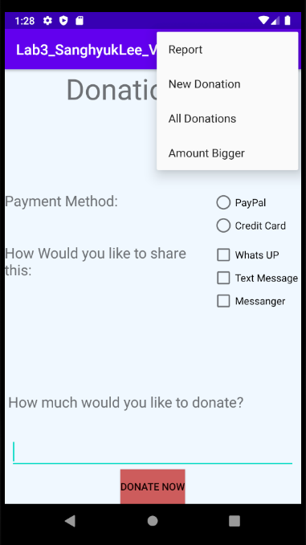

1. **Report**

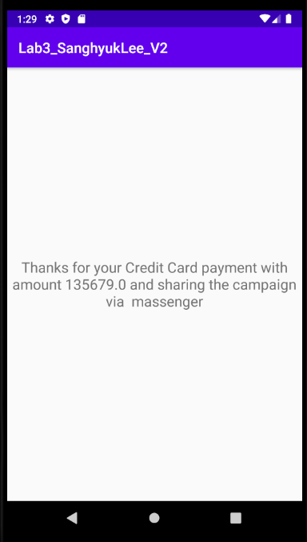

1. **All Donations**

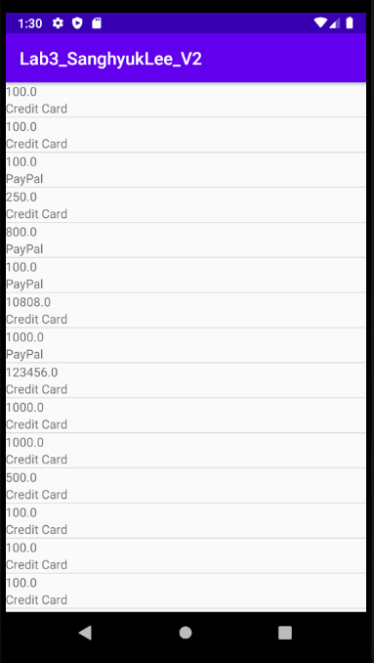

1. **All Donations which amount is more than 1000**

